Q1. Count the number of students in each major category.
Query:
select major_category,
count(*) as total_students
from pqr.import_of_ai
group by major_category;
Screenshot:
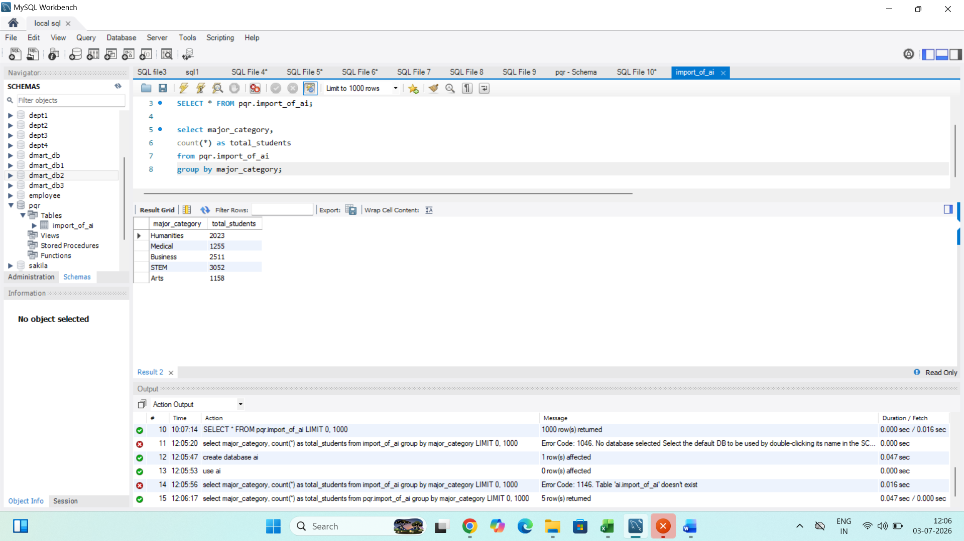

Insights:
1. compare the popularity of different academic majors.
2. STEM has the highest number of students (3,052),making it the most represented major.
3. Arts has the lowest number of student (1,158),indicating the smallest representation.

Q2. Find the dense rank of student based on skill retention score.
Query:
select student_id,
skill_retention_score,
dense_rank() over(order by skill_retention_score desc) as Student_rank
from pqr.import_of_ai;
Screenshot:
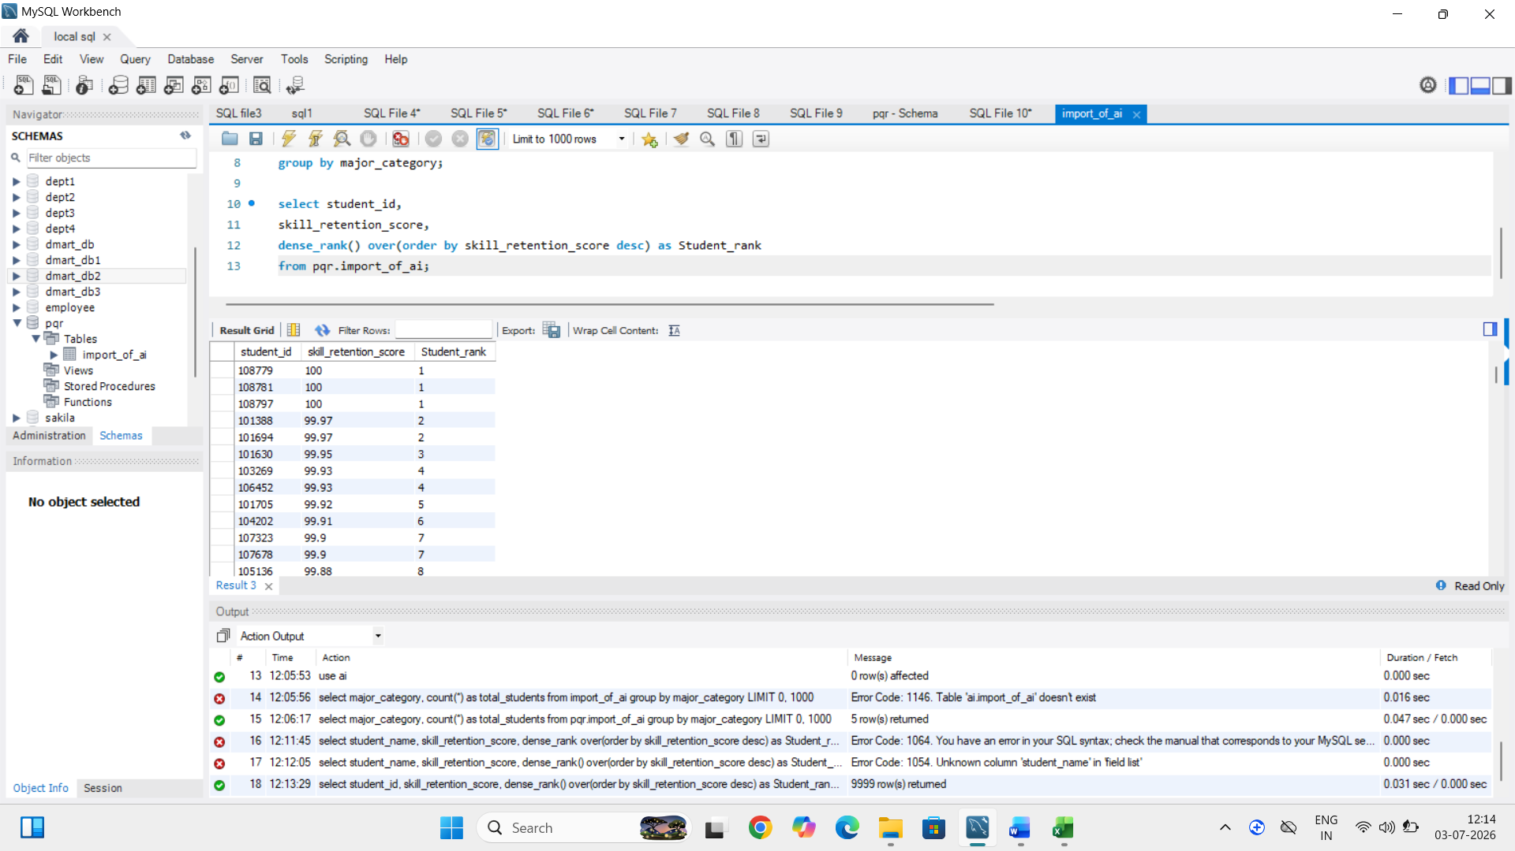

Insights:
1. Dense rank() does not skip rank number when there are ties.
2. 10,000 students, so the ranking compares every student’s skill retention.
3. highest skill retention score is 100 and the lowest is 13,23 showing a wide range of student performance.

Q3. Find the top 3 students in each major category.
Query:
select * from(select student_id,
major_category,
post_semester_GPA,
dense_rank() over(partition by major_category order by post_semester_GPA desc)as rank_no
from pqr.import_of_ai) as top
where rank_no<=3;
Screenshot:
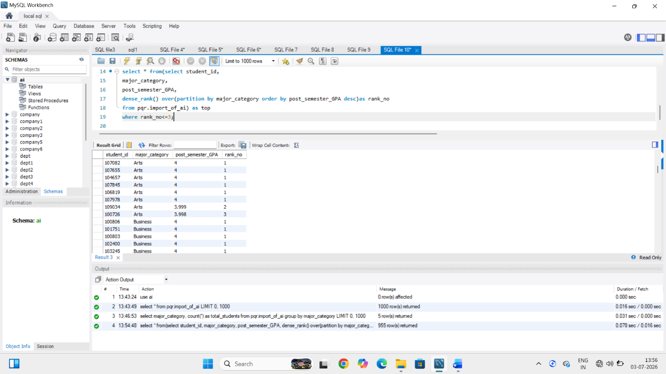

Insights:
1. Selecting the top 3 from each major highlights only the best academic performers.
2. Major category (STEM, Business, Humanities, Medical, Arts) has its own top 3 students based on the ranking criteria.

Q4. What is the average of pre semester GPA and post semester GPA.
Query:
select round(avg(pre_semester_GPA),2) as avg_pre_semester_GPA,
round(avg(post_semester_GPA),2) as avg_post_semester_GPA
from pqr.import_of_ai;
Screenshot:
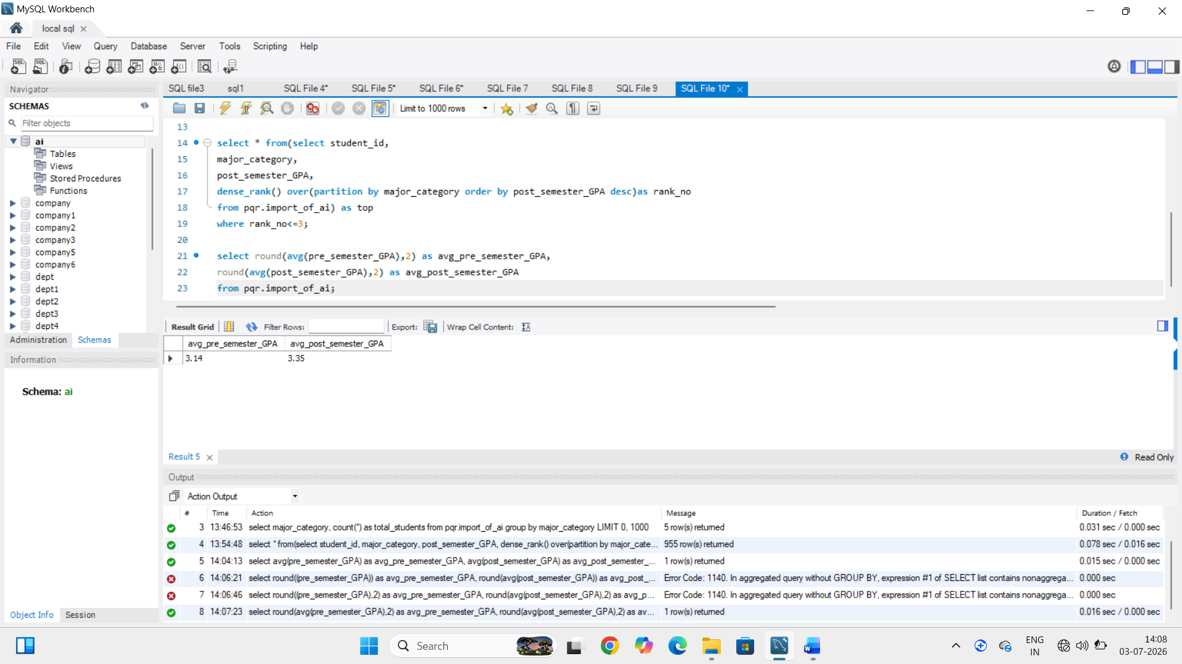

Insights:
1. Determine the students academic performance improved or declined after the semester.
2. average of post semester GPA is higher and pre semester GPA is lower.

Q5. Find ratio student whose post semester GPA is greater than their pre semester GPA.
Query:
select count(case when post_semester_GPA > pre_semester_GPA Then 1 END) as improved_students,
count(*) as total_students,
concat(
Round(
count(case when post_semester_GPA > pre_semester_GPA then 1 END) * 100.0 / COUNT(*),
2
),
'%') as improvement_ratio
FROM pqr.import_of_ai;

Screenshot:
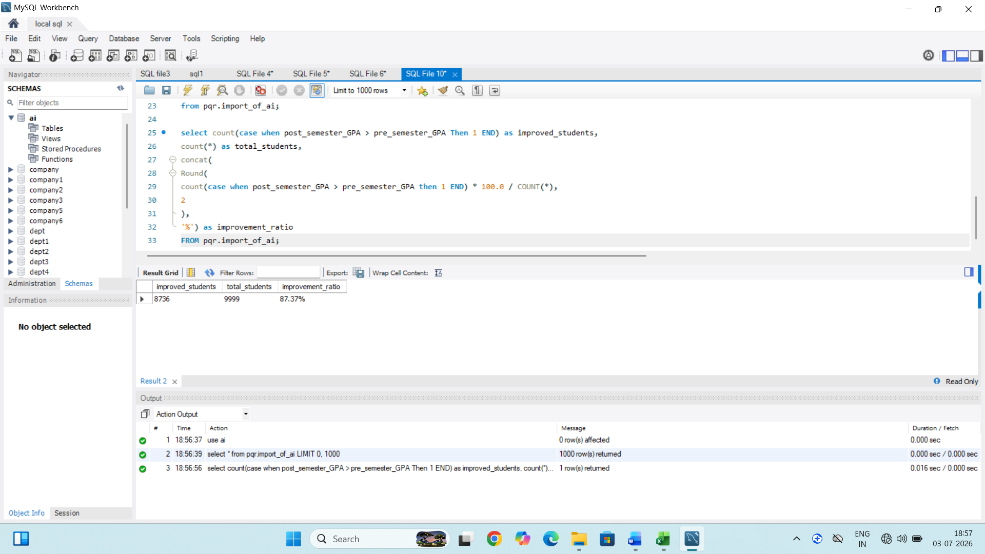
Insights:
1. a higher improvement ratio indicates that a large proportion of students performed better after the semester.
2. The overall academic improvement rate among all student.

Q6. Find the average post semester GPA, average pre semester GPA ,and the difference between them for all students.
Query:
select Round(AVG(post_semester_GPA),2)as avg_class_gpa,
Round(AVG(pre_semester_GPA),2)as avg_student_gpa,
Round(AVG(post_semester_GPA)- AVG(pre_semester_GPA),2)as gpa_difference
from pqr.import_of_ai;

Screenshot:
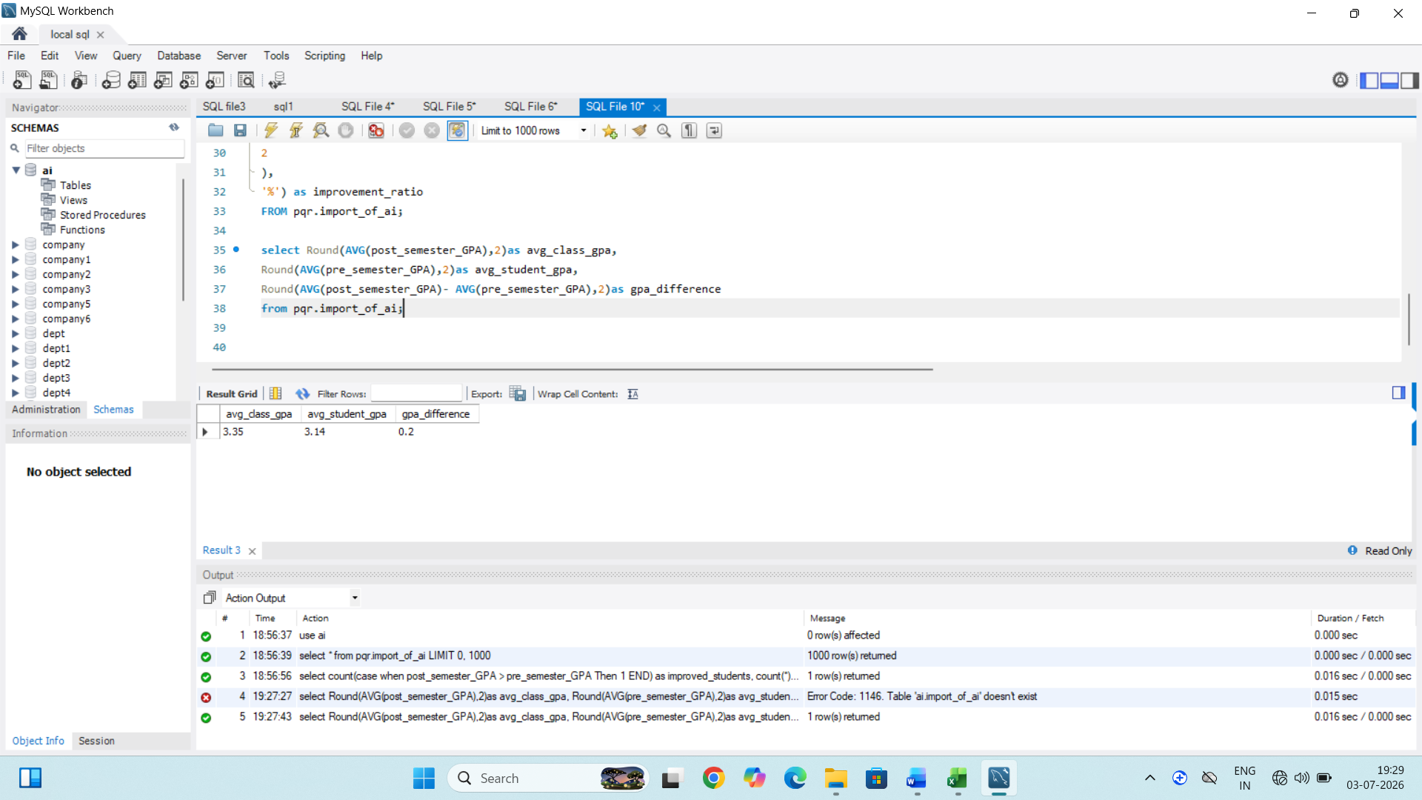

Insights:
1. calculate the overall average pre semester GPA and Post semester GPA of all students.
2.The GPA difference provides a simple indicator of the overall learning progress of student.

Q7. Find student whose post semester GPA is greater than pre semester GPA.
Query:
select student_ID,
pre_semester_GPA,
post_semester_GPA
from pqr.import_of_ai
where post_semester_GPA > pre_semester_GPA;

Screenshot:
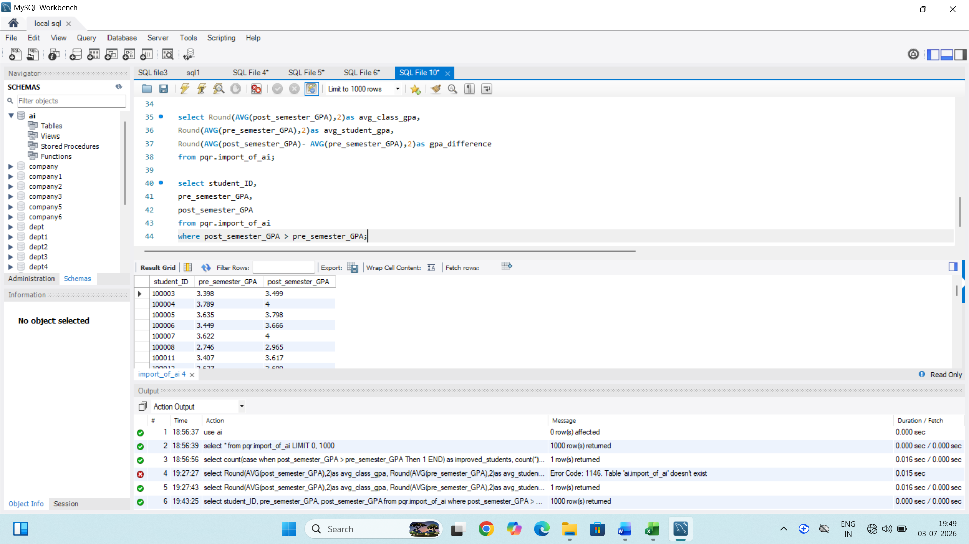
Insights:
1. student who achieved a higher post semester GPA than their pre semester GPA.
2. Student whose academic performance improved after the semester.

Q8. Compare ratio Student in each burnout risk level.
Query:
select Burnout_Risk_level,
count(*) as total_students,
Round(count(*) * 100.0/ (select count(*) from pqr.import_of_ai),2) as ratio_percent
from pqr.import_of_ai
group by Burnout_Risk_level
order by ratio_percent desc;
Screenshot:
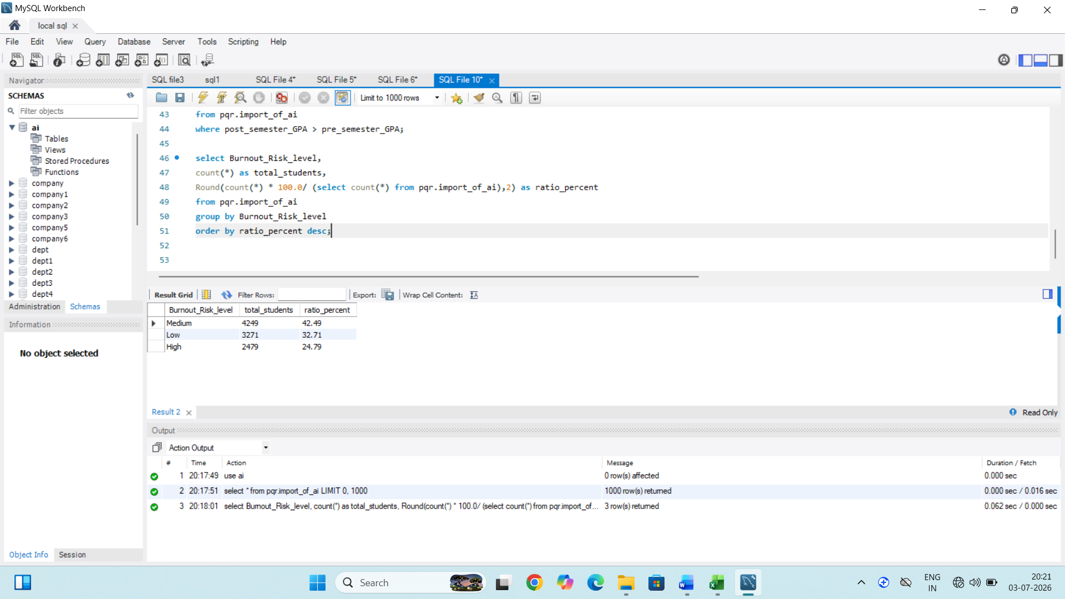
Insights:
1. classifies all students into different Burnout risk levels(Low,Medium,High).
2. Determine whether most students have low, Medium, high burnout risk.
3. Which Burnout risk level has the highest proportion of students.

Q9. Which major category spends the most time using GenAI.
Query:
select major_category,
Round(AVG(Weekly_GenAI_Hours),2) as avg_GenAI_hours
from pqr.import_of_ai
Group by Major_category
order by avg_GenAI_hours Desc
Limit 1;
Screenshot:
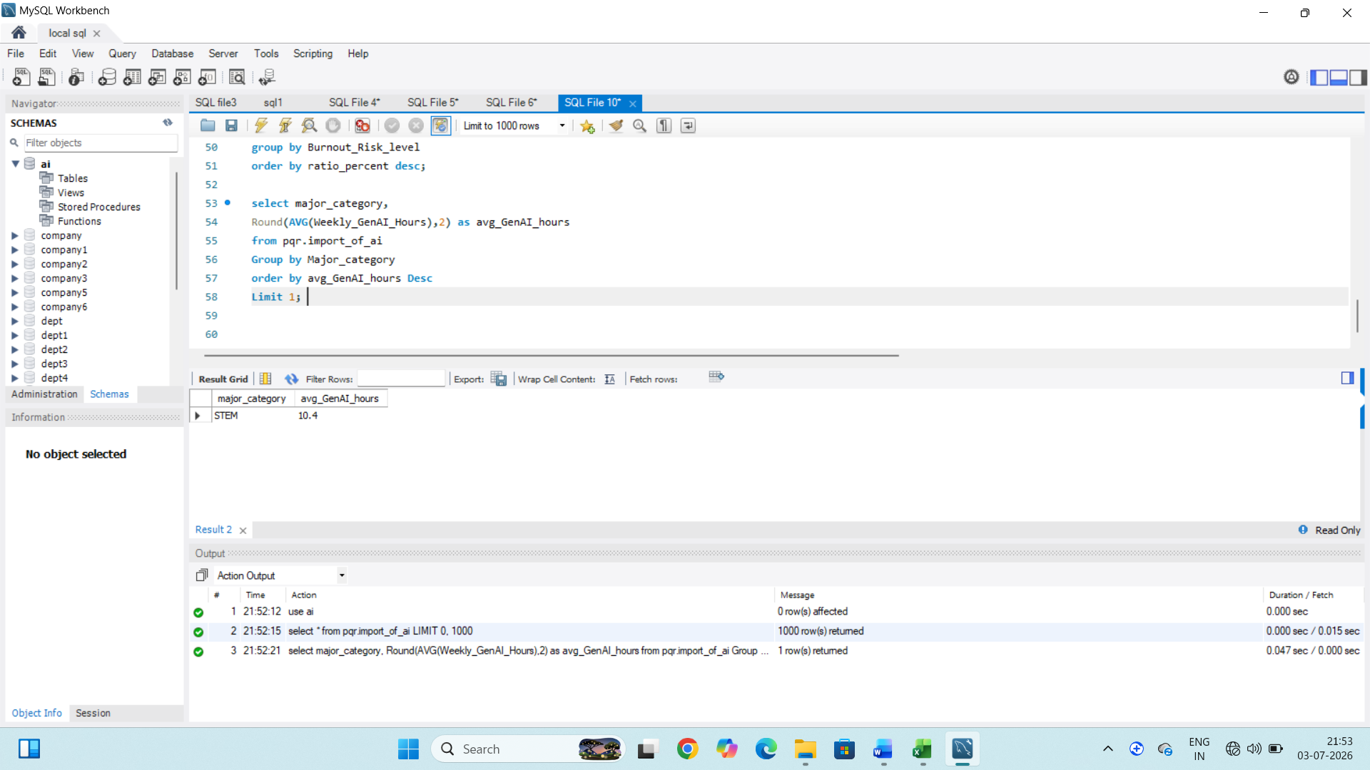
Insights:
1. The results help compare GenAI usage pattern across different major category.
2. the major category with the highest average GenAI usage time STEM use most time for major category.

Q10. Which year of study has highest or lowest avg GPA.
Query:
Highest:-
select Year_of_study,
Round(AVG(post_semester_GPA),2)as AVG_GPA
from pqr.import_of_ai
group by Year_of_study
order by AVG_GPA Desc
Limit 1;
Screenshot:
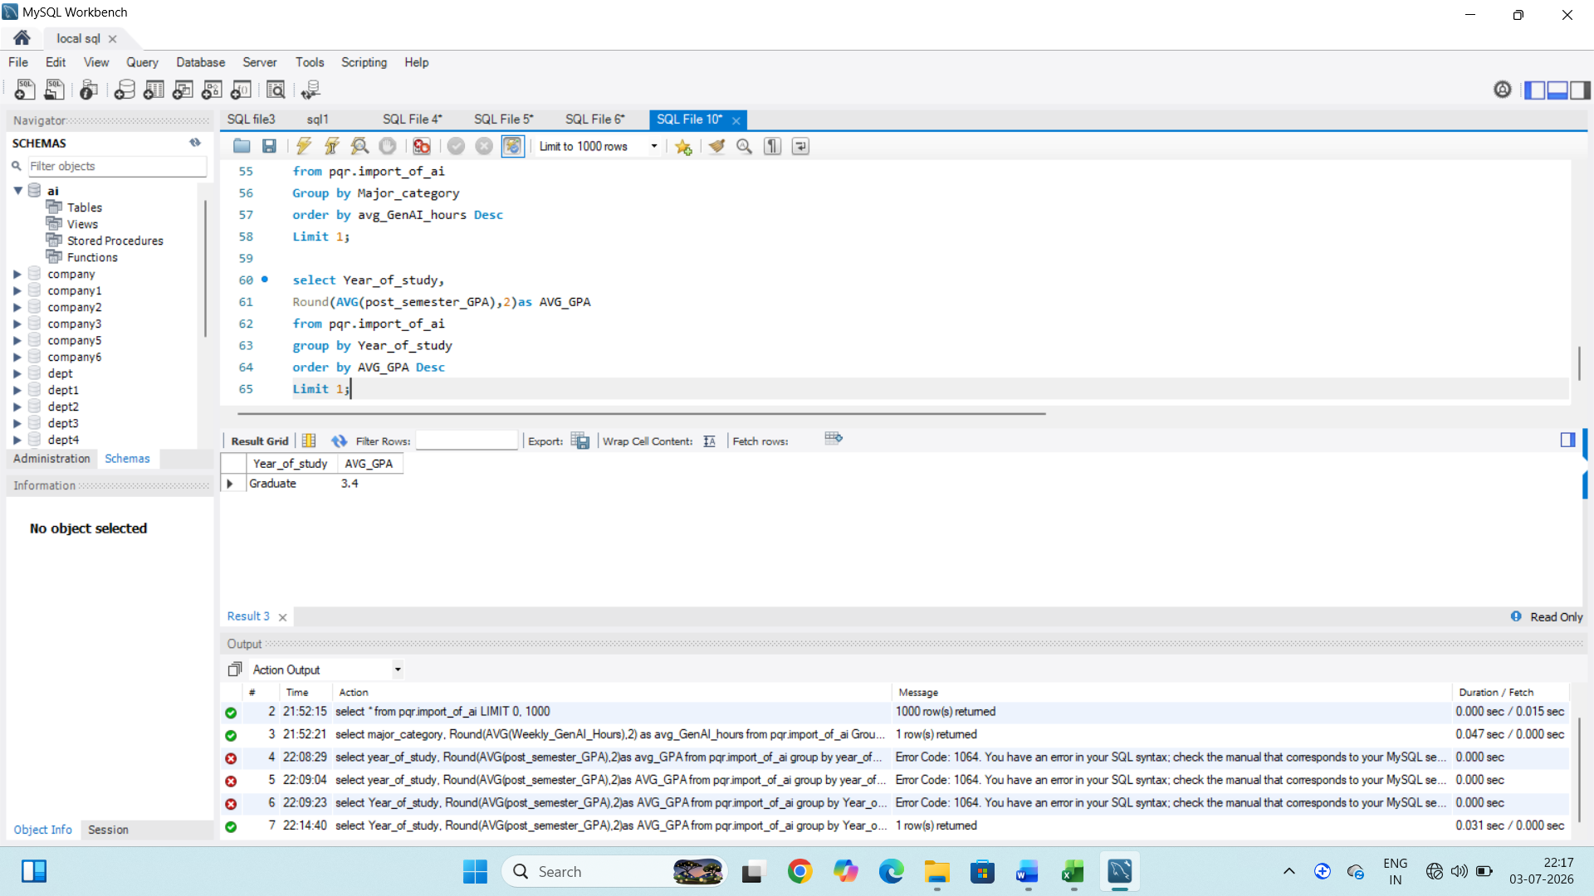
Insights:
1. compares academic performance across all years of study.
2. Graduate is highest AVG GPA for year of study.
3. highest average GPA may suggest that student that year have better subject knowledge, experience.

Query:
Lowest:
select Year_of_study,
Round(AVG(post_semester_GPA),2)as AVG_GPA
from pqr.import_of_ai
group by Year_of_study
order by AVG_GPA Asc
Limit 1;
Screenshot:
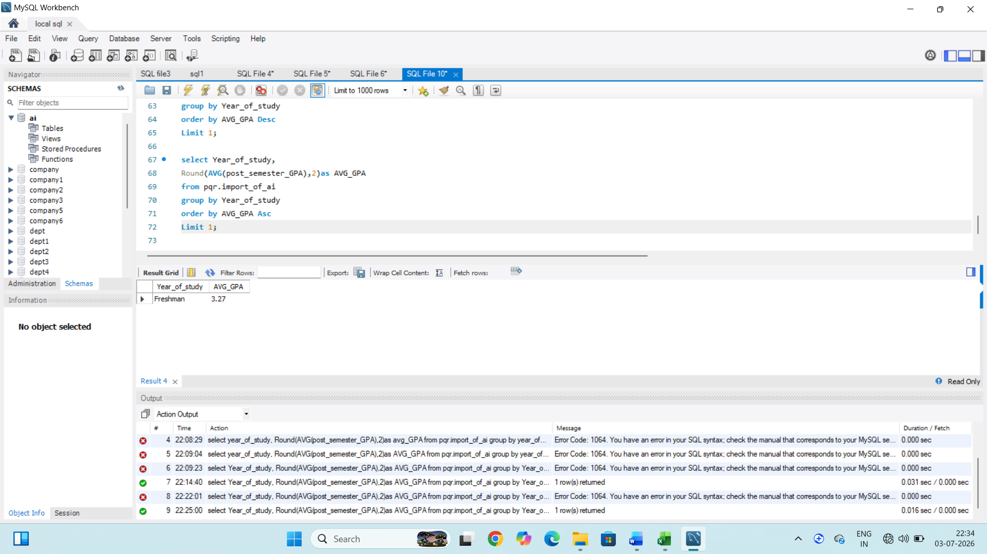
Insights:
1. freshman is lowest average GPA of year of study.
2. The student group that has the lowest overall academic performance.

